# Mechanical Design

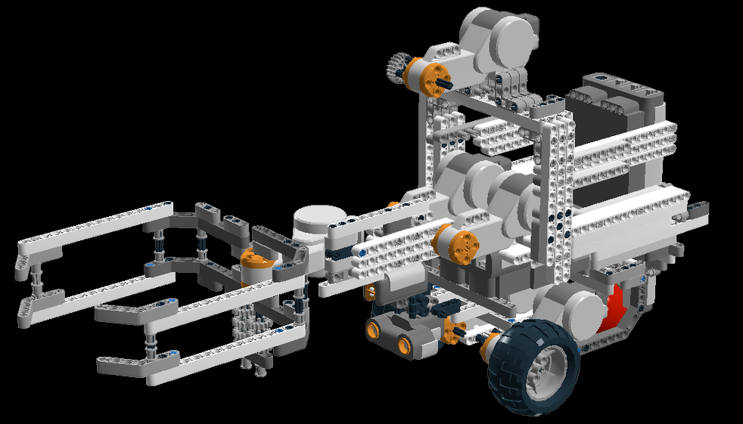

**Fig.1 (Overall View)**

**How many NXTs are we using and where are they?**

A total of 2 NXT bricks are being used. One is standing vertically at the back, and the other is located on top of the base. The position is chosen so that the robot is balanced and doesn’t fall.

**How many motors are we using and where are they? What is their purpose?**

This design uses a total of 6 motors:

* 2 motors for robot motion and rotation,
* 2 motors for handling(lifting and lowering) the arm
* 1 motor providing assistance when lifting the arm, through a string attached to the mechanical arm
* One motor to control the clamps used for grasping the object.

**How many sensors are we using and where are they? What is their purpose?**

There are 3 ultrasonic sensors: one at the front and 2 at the sides. All three are being used for obstacle avoidance. We have 2 light sensors: one for localizing at the back, and one in the front at the bottom. We could have used a 3rd light sensor attached to the arm in order to scan the beacon on an obstacle but we decided to at first focus on the “beacon is on the ground” part because of budget constraints, and then, if we have time, handle the “beacon on an obstacle” part.

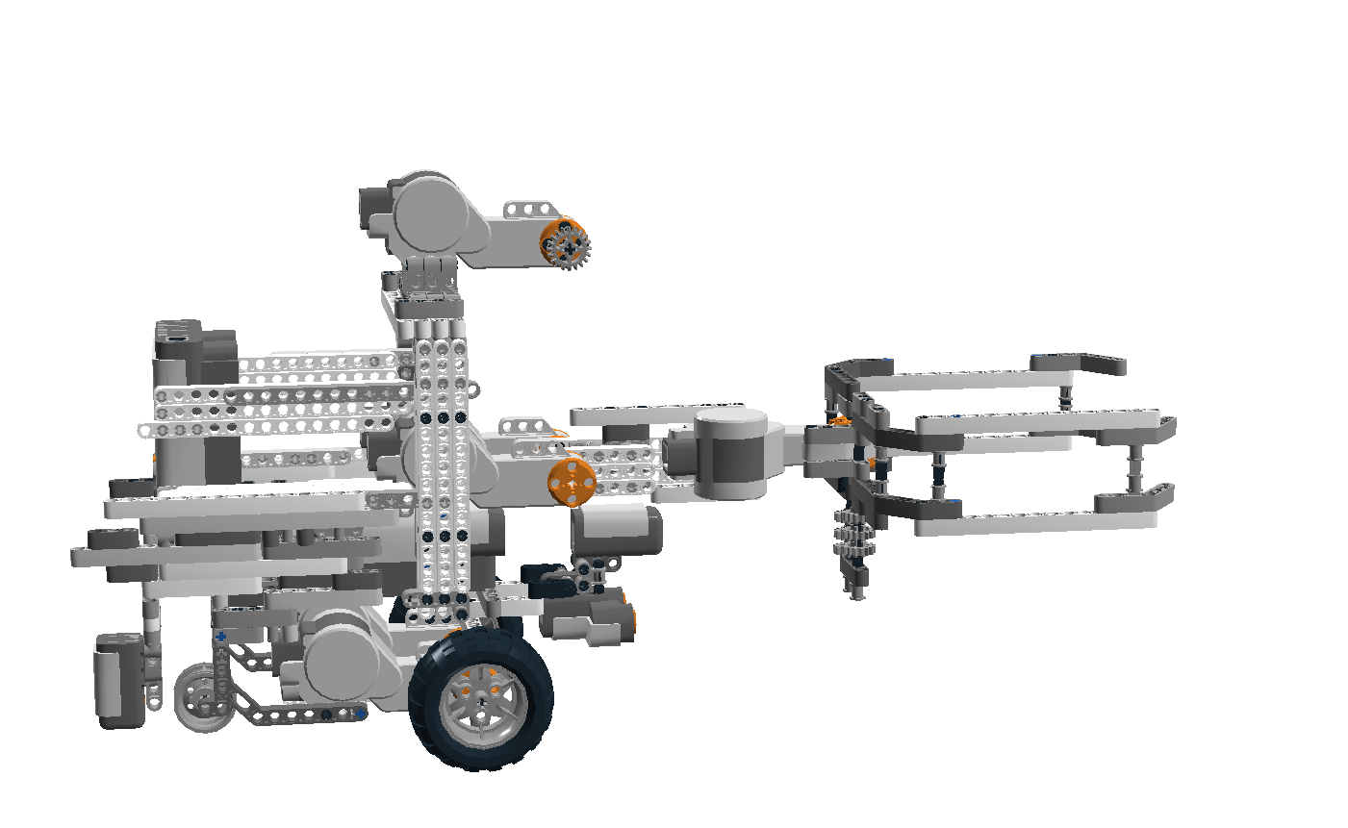

**Fig.2 (Side View without ball)**

**How does the different NXTs handle the motors and the sensors?**

One NXT brick controls the arm, including 3 motors and the 2 ultrasonic sensors at each side. The other NXT brick controls the 2 motors used for wheel rotation and the support motor for the arm. It also controls all 3 light sensors and the ultrasonic sensor at the front.

**How do the NXTs communicate with one another?**

They use Bluetooth connection to communicate with each other. We have a Master/Slave system where the slave (horizontal brick) controls the arm movement and gets the information from the Master brick by Bluetooth.

**How are we picking up beacon?**

When the light sensor detects the beacon, the 2 motors close to the arm adjust its level depending on the beacon position. The third motor supports the lifting of the arm through a string attached to the robotic arm. The robot then moves forward and, the clamps open, grasp the object, and then close. Once again, the 2 motors, with the aid of the support motor, lift the beacon.

**How do we satisfy the user requirements?**

The user requirement is for the robot to be capable of operating in 2 modes (attacker/defender) . In either case, the robot is required to first localize at (0,0) and then navigate its way across a

12 x 12 field, while avoiding obstacles along the way.

As an attacker, the robot will have to look for the beacon and then, once it has found it, place it at a coordinate given by a Bluetooth server. We are handling this by scanning while we move to the center of the field and once there turn 360 to look for the maximum luminosity. If found, we move towards the beacon and pick it up. If not, we follow the diagonal, go the opposite corner and look for the beacon again. At most times, as we’ve seen it while were doing the tests, it can see it from the middle of the field.

For the defender, the robot will detect and obtain the beacon (light source) at a given coordinate and then turn 360 to look for an obstacle if it hasn’t detected one yet. Once it detects an obstacle, the robot places it close to it and gets back to its initial coordinate.

At the beginning of every round, the robot localizes with the help of the light sensor at the back and then uses its front ultrasonic sensors to avoid the obstacles while navigating and also to register if there is an obstacle or not. It uses its front light sensor to detect the beacon. Once the location is identified, the robot proceeds towards the beacon and then grasps it using its clamps, before proceeding to the location stated in the instructions.

**What are the strengths of this design?**

Certainly the most powerful element of our robot is the design. It has strong base with a low center of gravity. It doesn’t tilt sideways or sag downwards, mainly because of the use of Play-Doh to strengthen the wheels and the use of an additional mass (6 more batteries) at the back. This is very important because it can affect the odometer and navigation. Furthermore, the robot is very compact around its center of gravity, which increases by a lot the stability.

**What are the weaknesses of this design?**

The fact that the arm cannot be elevated beyond a certain height due to the fixed position of the controlling motors can be a problem in the case where some teams place the beacon at the top of a vertical obstacle. This can be improved by the use of a longer arm and a most powerful motor, and more weight at the back (to balance). The grabbing part also doesn’t work at a satisfactory rate because the sandpaper that we use is not enough effective. It works 75% of times and, because of budget limitations, we decided that we will let it unchanged. A good improvement will be to change the sandpaper, or change the configuration of the claw by changing the angle of the clamp (an acute angle will grip more than a wider angle).

**Is there any material that we use and that it was not initially provided?**

* Fishing line: Needed to connect the arm to the support motor at the top,
* Tape: Used to hold the ball in place
* Rechargeable batteries and charger: Used instead of normal batteries as they are cost effective.
* Play-Doh: Used to strengthen the wheels

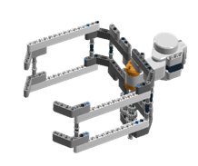 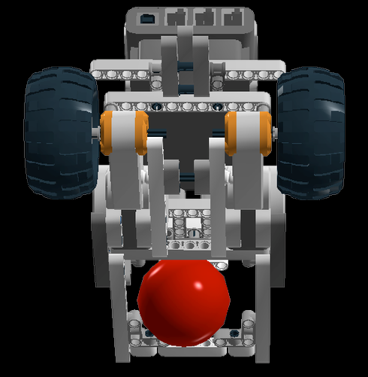

**Fig. 3 (The Clamps) Fig.4 (The base)**